The Process
Changing Paradigms
Prodigal Message #3

Weekly Memory Verse: Hebrews 12:11 No discipline seems pleasant at the time, but painful. Later on however it produces a harvest of righteousness and peace for those who have been trained by it.

Introduction
The majority of people who attend the Prodigal ministry walk through our doors in the midst of chaos and crisis. They are often desperate, depressed, frustrated and are in need of real answers. The reality is that it has usually taken years to get to this point and the complicated issues will not be solved overnight. There are no quick fixes. The journey, if successful, will be a “Process” that will take time and will consist of multiple small and large changes in viewpoint called paradigm shifts. This process, if navigated correctly, will lead to a transformation by a renewing of your mind that will bring you peace and joy in ways you never dreamed possible.

The Process : Transformation!
The Prodigal ministry is a discipleship ministry. As such, we must realize that discipleship is a lifelong journey of becoming more Christ-like. Everyone’s journey is unique, but we all share common experiences. Our lives change radically from the cradle to the grave as we grow in body, mind, and spirit. We will be shaped by our environment, parents, geographical location, and belief/faith systems. Our life experiences will impact and shape us mightily. Our life can be viewed as a long Process in which we “change our minds” often as we absorb new information and experiences.
As Christians the key paradigm shift in our lives is when place our belief in Jesus Christ’s death and resurrection as a substitutionary sacrifice for our sin so that we may experience abundant life now and eternal life with God. Romans 12:2 is a key scripture to keep in mind in our journey as it tells us that we are transformed by the renewing of our mind.
A reasonable question to ask is what are we being transformed from and what are we being transformed to. There are many ways to answer that question and the specifics will be different for everyone, but they can be summed up in John3:30 He must become greater; I must become less.

Our Hardships are Useful Opportunities
The transformation from a paradigm in which our world revolves around us to one that revolves around God is a difficult one indeed. This transformation process takes time but is usually hastened by the problems that are promised to face us all. (John 16:33) God’s word tells us that these problems and hardships are the very events that shape us into who we need to become.
- Hebrews 12 :7 Endure hardship as discipline. God is treating you as sons….v11 no discipline seems pleasant, but painful, later on however it produces a harvest of righteousness and peace for those who have been trained by it.
- James 1:2-4 Consider it pure joy, my brothers, whenever you face trials of many kinds, because you know that the testing of your faith develops perseverance. Perseverance must finish its work so that you may be mature and complete, not lacking in anything
- Romans 5:3-5 … we also rejoice in our sufferings, because we know that suffering produces perseverance; perseverance, character; and character, hope. And hope does not disappoint us because God has poured out his love into our hearts by the Holy Spirit, whom he has given us.
These scriptural examples and others point clearly to the value hardships and suffering have on all of us who want to grow into the person God wants us to be and to experience the abundant life he wants for us. Since that is the case, then we must look very closely at our prodigal journey.. We have an opportunity to be transformed by it.
This transformation is a process that takes TIME, and occurs through a series of paradigm shifts.. This message will address the Prodigal “Process” and the “paradigm shifts’ required along the way.

LIFE MAP
Christ-likeness
hardships/troubles
Paradigms
A paradigm can be defined in several ways but for the purpose of this talk , Webster’s definition helps. “A philosophical or theoretical framework of any kind or a theory or a group of ideas about how something should be done, made, or thought about.” Simply stated a paradigm is a framework of how we view things. How we view and think about issues may change over time based on experience, increasing insight and knowledge. These changes are called paradigm shifts.

Success Paradigms
Steven Covey in his book, “7 Habits of Highly Effective People” reviewed 200 years of “success literature”. What he found was very interesting. The first 150 years consisted of a “Character Ethic” paradigm for success. During this period success literature promoted that success was a byproduct of a long steady process in which one prioritized a life of integrity, humility, fidelity, modesty, temperance, courage, justice, patience, simplicity, and following the Golden Rule. These basic principles of effective living must be ingrained into basic character to experience true success and enduring happiness
In the past 50 years a surprising new paradigm has emerged. Covey called this paradigm a “Personality Ethic”. Success, under this perspective, is viewed more as a function of personality, image, attitudes, behaviors, skills, and techniques than character. Such a paradigm plays out by building a quick perception of the truth, which may not be true at all. Techniques are quick fixes and center on public relations and marketing techniques as well as the power of positive thinking in which you convince yourself that you are your own God, even if those actual words do not come out of your mouth. Your actions with such a perspective belie your beliefs however.

Paradigm shifts are very difficult to make because change is hard and uncomfortable. Change can be very scary at times. That is why it usually takes time to change and there are no quick fixes. We are comfortable where we are in most instances, so it usually takes something substantial or dramatic to finally realize that we must change our way of thinking; our paradigm. Refusal to change paradigms is the leading reason participants leave the program early and the leading reasons chaos continues.

The Power of a Paradigm
OUR PARADIGMS ARE DETERMINED BY BIASES WE ARE OFTEN UNAWARE OF.
Experiment : The Power of a Paradigm

IF YOU CAN BE DISCIPLINED ENOUGH FOR THIS EXPERIMENT, VIEW ONLY THE LEFT OR RIGHT SKETCH BELOW FOR 30 SECONDS THEN VIEW THE SKETCH BELOW THEM ANSWERING THE QUESTION ABOVE IT.

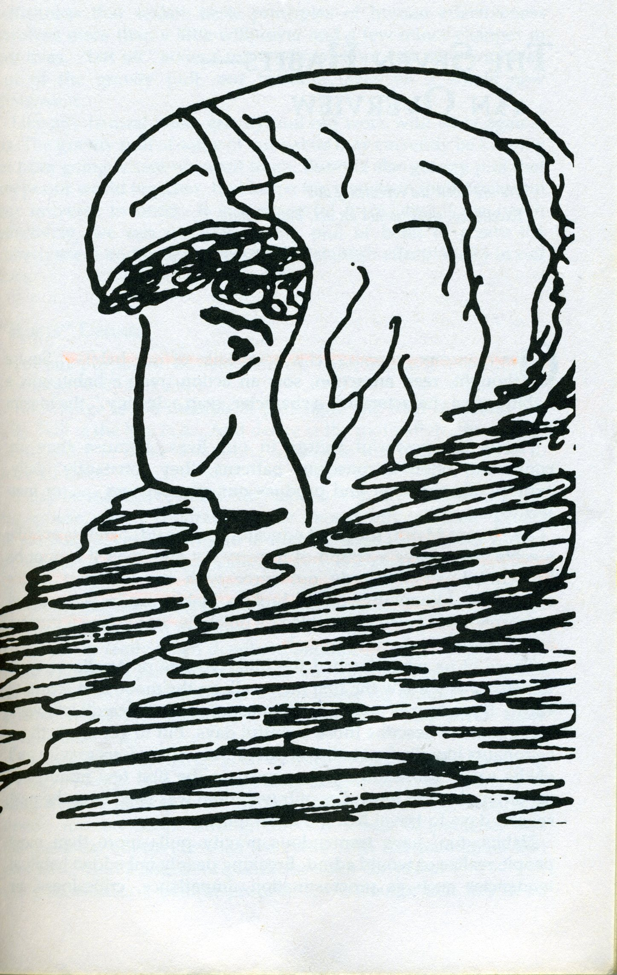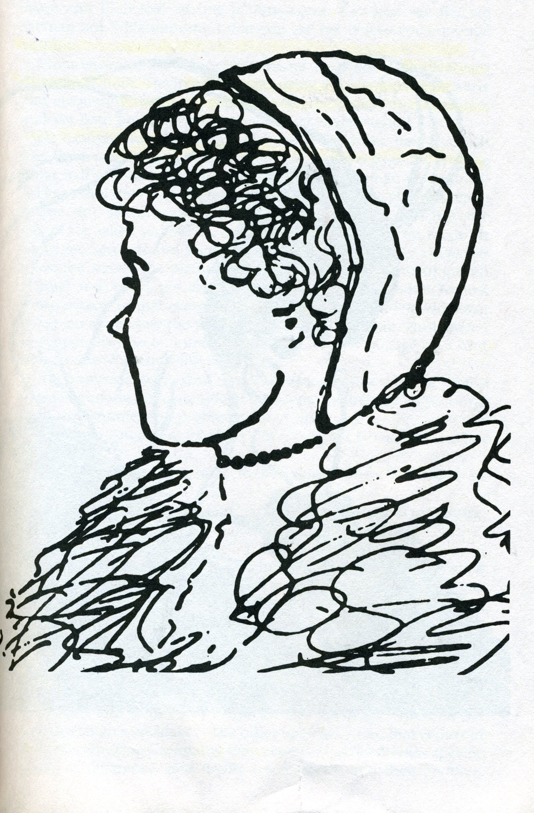

DESCRIBE THE LADY YOU SEE IN THE PICTURE BELOW….OLD? YOUNG? BEAUTIFUL? UGLY?

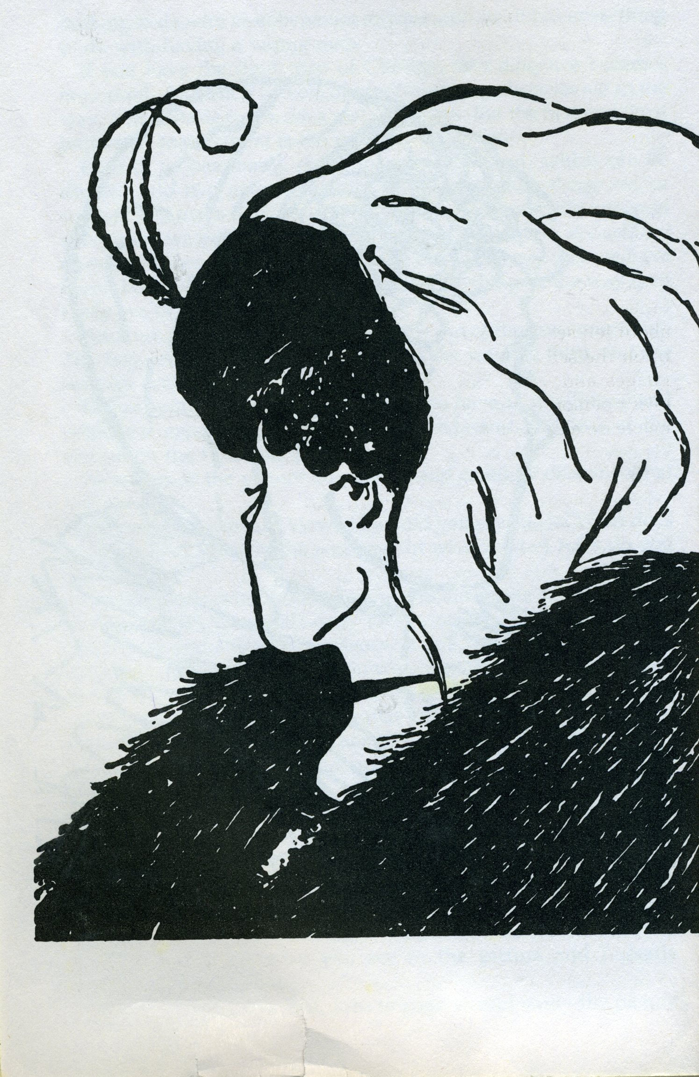

Most people will be biased by the first photograph they viewed. The initial photos were biased towards either an old ugly lady or the young beautiful lady. Those original photos usually cause you to have a certain paradigm when viewing the subsequent photograph. It is often interesting to see people disagree passionately about the truth they see in the final photograph. They are often so biased that they are unwilling to open their minds to another viewpoint and will argue vehemently their position. The point is that we are biased by our embedded paradigms. Our biases may be influenced by geography, family, politics, fears, religious beliefs, or social beliefs. We must be willing to humbly, honestly, and openly evaluate our paradigms in our search for Truth.
We can achieve minor changes with simple attitudes or behaviors, but significan’t long term change requires a paradigm shift based on solid principles ie…Truth. The more our paradigms are based on solid Truth, the more we can depend on them in our journey. The more they are based on Biblical Truth the more powerful they are in shaping us to be the Godly men and women we are want to become.

How Do Paradigms Change?
Change of paradigms are most often prompted in life threatening crisis, “ah ha” moments, or moments of vulnerability and openness. In those moments we often realize that we need to gain wisdom and new insight and our paradigm may not be based in truth. One particularly vivid example was told by Frank Koch in Proceedings, the magazine of the Naval Institute.
Two battleships assigned to the training squadron had been at sea on
maneuvers in heavy weather for several days. I was serving on the lead
battleship and was on watch on the bridge as night fell. The visibility was
poor with patchy fog, so the captain remained on the bridge, keeping an eye
on all activities.
Shortly after dark, the lookout on the wing of the bridge reported, “Light,
bearing on the starboard bow.”
“Is it steady or moving astern?” the captain called out.
Lookout replied, “Steady, captain,” which meant we were on a dangerous
collision course with that ship.
The captain then called to the signalman, “Signal that ship: We are on a
collision course, advise you change course 20 degrees.”
Back came a signal, “Advisable for you to change course 20 degrees.”
The captain said, “Send, I’m a captain, change course 20 degrees.”
I’m a seaman second class,” came the reply. “You had better change course
20 degrees.”
By that time, the captain was furious. He spat out, “Send, I’m a battleship.
Change course 20 degrees.”
Back came the flashing light, “I’m a lighthouse.”
We changed course.

Trustworthy Principles are like lighthouses,; steady, reliable, and unchanging. Prodigal principles are the truths of God’ Word , which are guiding us away from the rocks of life. You must decide if you are going to believe and obey these truths (obedience) or argue with the lighthouse (disobedience) The more our paradigms align with God’s truths, the more we will be on course and at peace resting in God’s will for our lives.
Hopefully you are beginning to appreciate that the way we see the problem (our paradigm), might be the problem! When struggling with a particularly troublesome issue, we must always be willing to ask ourselves if there could there be something we need to see in a deeper, different or more fundamental way? We should question if there is some paradigm within ourselves that blinds us to the truth that we should see in our own life or the life of our prodigal ?
We then might ask the chilling and eye opening question, “Could this really be about me? Does God want me to use this for my transformation to be more like Christ and for His glory? Really?” It is healthy for every person to ask the right questions and decide confidently on what principles they should base their life on and what principles they will follow in their Prodigal Process.
Paradigm changes occur when people hit their bottom. We pray that for our prodigals, but surprisingly it must happen to us. It has been said by many, “if you like where you are, keep doing what you are doing!” Another viewpoint is that you must become sick and tired of being sick and tired. You must get to a point when you are willing to change your paradigms in this process.
Said in another way, pride is a stumbling block to change. Fear is seen as a stumbling block to change, but again, the source of this fear is pride thinking that you have more control over the situation than you do. Humility and brokenness, leading to faith in a good God, is the key to unlocking the door to change which, can create helpful paradigm shifts.

The most critical Paradigm to consider that helps you answer the questions above centers on the answer to this question.
Who is God and what are your views about God ?
“What comes into our minds when we think about God is the most important thing about us.” A.W. Tozer
As Tozer proclaims in his famous quote above, what we think about God and his attributes will determine if you will allow him to be God instead of you. So before you answer a larger paradigm of who God is in your life, you must consider more basic questions to lead you to the larger paradigm. Some questions to consider….
- What is your opinion of God?
  - Is he really Good in all circumstances?
  - Is He always Faithful?
  - Is He Unconditionally Loving
  - Is He Omniscient, Omnipresent, Omnipotent
  - Etc….
- Is God alone ENOUGH for us in every way
Once we answer these questions and really define what we really think about God, then we must finally answer one of the most important paradigm decision in a human’s life. It is certainly the most critical paradigm in your prodigal journey.
The question is “Who is God in your life”? There are really only two options.
If We are God -Prov 14:12
- We are in control
- It’s all about us…our needs, our perception and value by others
- If I can fix my prodigal, my life will be back to “normal”
- Our vision is comfort now and peace in the home at any cost
If God is God (eternal) -Prov 19:21
- We are not in control
- It’s all about God…our relationship with Him and serving Him is paramount…using prodigal chaos as an instrument to grow closer to God
- Our joy is independent of “fixing” our prodigal or really any other circumstance
- Our vision is seeing Jesus face to face..fixing our eyes on Jesus so that we might have joy now and eternity thereafter

The Prodigal Journey/ Process
The Prodigal journey is a journey like any other journey. It begins from where you are now to a place you want to end up. You will most likely need to change paradigms along the way and that is why we have explored paradigms at length so far in this lesson.
Our starting point for our Prodigal journey is not a physical location, but rather a spiritual location. We often are not entirely accurate at assessing our own spiritual state. The questions listed below are asked by Tozer to gain a greater self awareness. The answers would gain even greater value if processed by a community that knows and loves you. Answer these questions honestly as a start.
Where are you NOW: Self Assessment (Tozer)
- What do you want most ?
- What do you think about most ?
- How do you use your money ?
- What do you do with your leisure time ?
- What company do you enjoy ?
- Who and what do you admire ?
- What do you laugh at ?

Once you have a clear vision of where you are, then you need to make sure you know where you want to end up. How do you want to live your life? What would a win look like if you lived your life in a certain way? We will have an upcoming entire lesson on this topic, which will help you determine your own personal mission statement and define your own specific purpose in life. However let’s assume for right now that you feel that living your life wholly for Christ and glorifying God would be a great place to end up. So what does the Bible tell us about a person with this paradigm looks like?
What is the END GOAL : A Biblical Vision of TRUTH….to be like Christ
- Phil 4:8 whatever is true, whatever is noble, whatever is right, whatever is pure, whatever is lovely, whatever is admirable- if anything is excellent or praiseworthy- think about such things
- II Cor 6:14 do not be yoked with unbelievers
- Matt 6:19 …your treasure is where your heart is…
- Matt 6:24 …no one can serve two masters…
- Gal 5:22 love,joy, peace, patience, kindness, goodness, faithfulness, gentleness ,and self control…
No person is free of sin this side of heaven, but ultimately a person striving to serve God begins to model many of these attributes, but also their view of God changes as they begin to believe passionately that God is in control. He is to be trusted because of His many attributes, not the least of which is His grace and love for us. We must rest knowing He cares and He alone is enough.

Practical Prodigal Paradigm Considerations
A critical paradigm to consider is your expectations for your prodigals. What are healthy expectations for our children/spouses/siblings? In setting such expectations we must also think about our perception of our prodigals in relation to how they measure up to our expectations. Our expectations can be athletic or artistic achievements or educational degrees. We can come close to expecting perfection from our spouses and children. In many cases our expectations are just “planned disappointments”. We must be careful to determine the proper paradigm of expectations.
A healthy parenting paradigm would be to let the child emerge and try to limit or certainly control our expectations. Maybe the only expectation would be for our prodigals to follow God. This might be a new paradigm to consider. You might ask yourself for the first time, “Is following God enough? Such a paradigm would begin to allow your prodigal to make decisions on their own. They might hear a different message from you. “We don’t need to protect you.” “You have the tools you need.” “You are going to make it“. “You have what it takes to figure this out on your own”
Think about the alternative message when you try to parent your child or manage/control your spouse . Every time you step in and rescue your prodigal you are sending the message that they are incapable, a failure, and you don’t believe they can do it.
As you consider new paradigms in your prodigal journey it might help for you to think about the answers to the following questions
- Do I really have to have my son or daughter achieve ____ for them to be happy….or for me to be happy and have my needs met?
- Is a felony arrest a deal killer ? (what if that was the bottom they need?)
- If our prodigal chaos is exposed to the world…child’s heroine addiction, husband’s pornography, gambling, alcohol addiction…is that the disaster I have always envisioned ?
- Is my relationship and walk with God really all that matters at the end of the day?
- Is my happiness the most important thing in life?
- If you are afraid your prodigal will die if left on their own…
  - Do you believe you actually have the power to save them (Prov. 21:31)
  - Do you believe it is your job to “save them” or do you believe you will have to answer to God and give an account ?
  - Look up and consider these verses as you contemplate these questions
  - Prov 29:15, 17, 19, 21
  - Prov 19:18,19
  - Heb 12:1-13
  - Ezekial 33:1-10
Also consider these quotes about the paradigms that may define us at times
- Wagner “if you like where you are, keep doing what you are doing.”
- Einstein “ the significant problems we face cannot be solved at the same level of thinking we were in when we created them.”
- Proverbs 14:12 There are ways which seem right to a man but in the end they lead to death

Application
In your prodigal journey as well as life’s journey you do not get there in a day. Such a healthy paradigm starts where you are now, and day by day you dig deeper into the Word and you process it in community. You have daily time in prayer and reflection with the Lord and you fall more in love with him. You begin to trust him more deeply and fully to the point of giving your prodigal to Him. This is the spiritual transformation that Paul talks about in Romans 12:2 that occurs by the renewing of your mind. Renewing your mind occurs through the disciplines above that result in small and steady paradigm shifts that leads to the ultimate paradigms that we have described. These disciplines are the tools to apply in your current prodigal journey but also the tools to apply every day for the rest of your life as you journey all the way to eternity.
Spiritual disciplines, guided by the Holy Spirit, acquired through Salvation
  - Bible Study -daily time in the Word or Truth(II Tim. 3:16, Hebrews 4:12.13))
  - Community…The Word processed and sharpened by the biblical wisdom of fellow believers you live life with(I Thess. 5:14)
  - Prayer…there is a battle for your Prodigal in the heavenly realms, so prayer is a powerful and necessary tool (Eph. 6:12)
Possible Practical Applications (today!)
For many of you, these disciplines are useful tools you are very familiar with. However for those of you who don’t know where to start, here are some simple, but possible first steps that you can begin today.
- Implement a daily Biblical reading plan as a priority
- Process your reading with your Biblical community (if you don’t have one, get one!)
- Pray daily for yourself and for your prodigal
- Solitude / listening / worship / gratefulness
- Work on your marriage
- Show up next week to Prodigal and keep coming
- Ask a friend or total stranger to Prodigal/serve

Conclusion and Call to Action
What we have just described is the Process that is before you in this ministry. The transformational journey that we have described takes time and effort. There are no quick fixes. The journey is well worth it, for once you learn the Truth about God in your Prodigal journey, then that Truth never changes. That Truth will guide you and lead you not only in your Prodigal journey, but that Truth will sustain you the rest of your life as you face the trials and troubles to come.
God does not make mistakes and He has known you would be experiencing this from eternity past. He is giving you the opportunity to use this painful experience to be trained in righteousness and to glorify Him. The choice is yours. We do not want to be overly dramatic, but we are not promised tomorrow. We have no way of knowing if God in His mercy will give you other chances to grow closer to Him and experience His love in ways beyond what you imagined possible. However, I doubt if those opportunities will come on mountaintops. They might. Most come from painful experiences found in the valleys of life. Just like the valley you find yourself in right now. We pray you enjoin this process and be willing to consider the paradigms that will guide your life. We do not want to overstate their importance or be melodramatic, but how you handle this opportunity will define you and will greatly impact the course of your life.

We close with an incredible perspective from Oswald Chambers on the Process.

We are apt to imagine that if Jesus Christ constrains us, and we obey Him, He will lead us to great success. We must never put our dreams of success as God’s purpose for us; His purpose may be exactly the opposite. We have an idea that God is leading us to a particular end, a desired goal; He is not. The question of getting to a particular end is a mere incident. What we call the process, God calls the end.
What is my dream of God’s purpose? His purpose is that I depend on Him and on His power now. If I can stay in the middle of the turmoil, calm and unperplexed, that is the end of the purpose of God. God is not working towards a particular finish; His end is the process—that I see Him walking on the waves, no shore in sight, no success, no goal, just the absolute certainty that it is all right because I see Him walking on the sea. It is the process, not the end, which is glorifying to God.
God’s training is for now, not presently. His purpose is for this minute, not for something in the future. We have nothing to do with the afterwards of obedience; we get wrong when we think of the afterwards. What men call training and preparation, God calls the end.
God’s end is to enable me to see that He can walk on the chaos of my life just now. If we have a further end in view, we do not pay sufficient attention to the immediate present; but if we realize that obedience is the end, then each moment as it comes is precious.
“My Utmost for His Highest” - July 28.
Oswald Chambers

