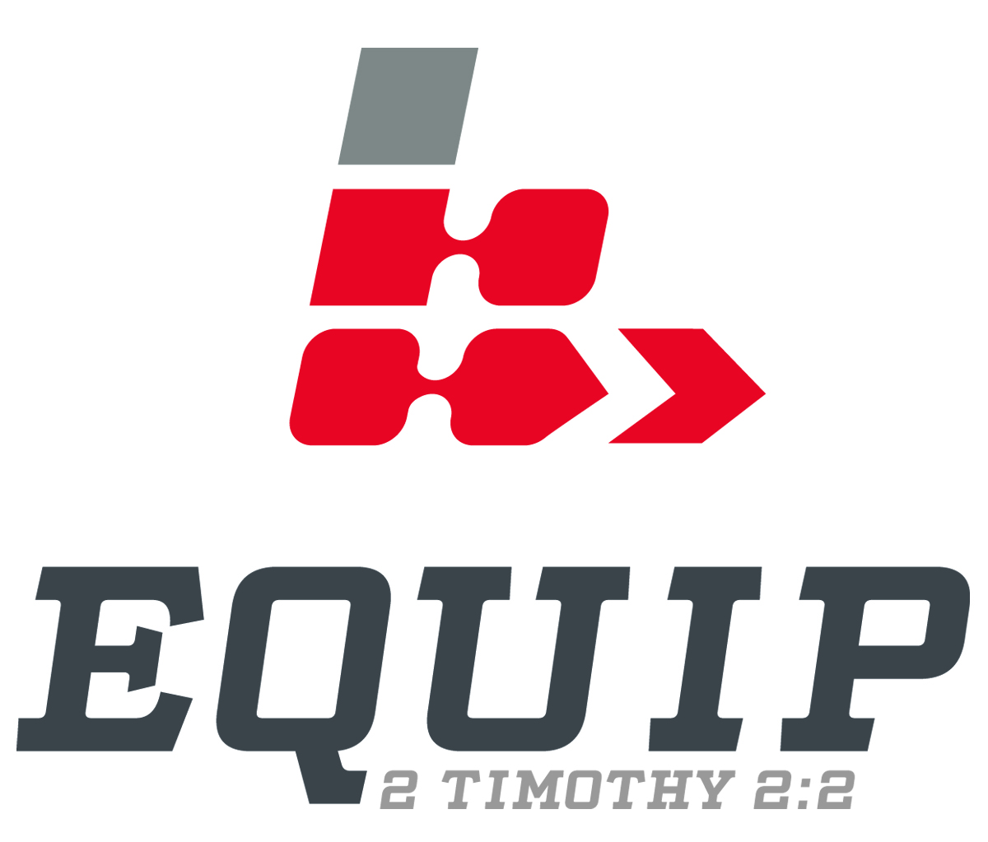

Observation

Observation is the means by which one answers the question, “What do you see?”

Five Questions to Ask when Observing:

- Who?
- What?
- When?
- Where?
- Why?

Elements of Observation:
- Repetition
1 John 2:15-17
- Contrast
Proverbs 15:1
- Comparison
James 3:3-5
- Lists
Galatians 5:19-23
- Cause and Effect
Romans 12:2
- Figures of Speech
- Simile – Matthew 23:27-33
- Metaphor – Revelation 17:3, 9
- Paradox – Mark 10:43-44
- Hyperbole – Matthew 5:29-30
- Euphemism – Ruth 3:4
- Conjunctions
Romans 6:23
- Verb Tense and Voice
Colossians 3:1
- Pronouns and Referents
Ephesians 1:3-8

- General to Specific
Galatians 5:16-23
- Specific to General
1 Corinthians 13
- Question and Answer
Romans 6:1, 15
- Dialogue
John 4:7-26
- Purpose and Result
John 3:16
- Means
Romans 8:13
- Conditional Clauses
2 Corinthians 5:17
- Emotional Terms
Matthew 23:37-38
- Unusual Words
Exodus 28:30
- Major Shifts
Romans 7:24-25
- Names for God
Ephesians 2:13, 18

Acts 1:8

“But you will receive power when the Holy Spirit comes on you; and you will be my witnesses in Jerusalem, and in all Judea and Samaria, and to the ends of the earth.”

Acts 1:8

“But you will receive power when the Holy Spirit comes on you; and you will be my witnesses in Jerusalem, and in all Judea and Samaria, and to the ends of the earth.”

