Session 1: Agents of Biblical Change

Ephesians 4:1-16

Jeremy Pierre

Introduction

Ephesians 4:1-16

- Christ causes growth in his people.

- His people cause growth in one another’s lives.

Helpful Grid
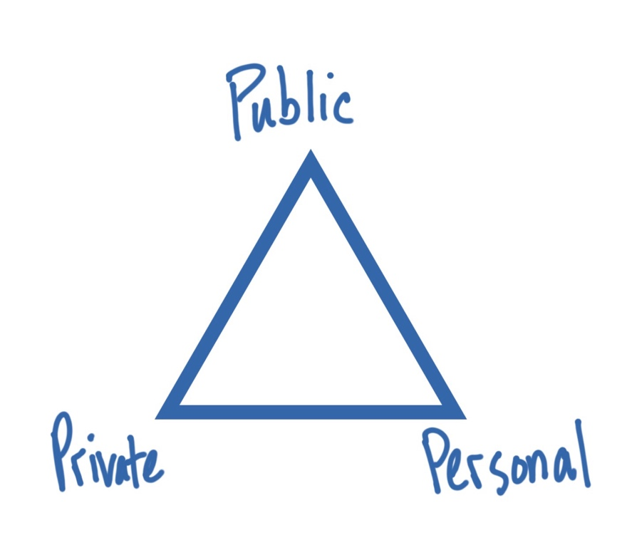

- Public Ministry of the Word:
The people of God gather to worship under his Word

- Private Ministry of the Word:
Each follower of Christ seeks to worship God alone under his Word

- Personal Ministry of the Word:
The people of God fellowship under the Word to speak to one another in the various ways Scripture models (encourage, comfort, forgive, exhort, admonish, warn).

Session 2: Helping Others Pursue Change by
Understanding Their Experience Biblically
Dr. Jeremy Pierre

Introduction

God designed you to experience the world as a person made in his image—that is, as people designed to think, to feel, and to choose. His love transforms the full breadth of who you are.

Simple Versus Complex Approach

Main Idea
Helping other pursue biblical change means in part helping them understand their experience biblically.

God designed you to experience the world as a person made in his image—that is, as people designed to think, to feel, and to choose. His love transforms the full breadth of who you are.

Jesus’ three dimensional approach to human experience.

- Cognitive Knowledge (John 16:13-15)

- Affective Feeling (John 16:20-24)

- Volitional Action (John 16:23-24)

Application: Consider how your personal ministry may be lopsided, emphasizing one aspect of the heart’s function at the expense of the others.

What does a person need in counseling?
- Does his intellect need to be instructed?
- Or, do his emotions need to be explored and directed?
- Or, does he need to make better choices?

- Cognition: Do not ignore a person’s interpretation of their situation; it shows what they believe most strongly.

Then, you rely on the power of Scripture to give greater knowledge, leading to a better understanding of their experience.

- Affection: Do not ignore a person’s feelings about their situation; it shows what they want most strongly.

Then, you rely on the power of the Word to challenge deeply held desires, leading to truer emotions in their situation.

- Volition: Do not ignore a person’s choice in their situation; it shows what they are committed to most strongly.

Then, rely on the power of the Word to inspire better commitments, leading to better choices in their daily life.

Discussion Question: When you minister to people, do you tend to address primarily the way they think, the way they feel, or the way they act? Why do you think that is?

Session 3: Biblical Change Applied to Anxiety
Dr. Jeremy Pierre

Introductory Thoughts

Simplistic Versus Dimensional Use of Scripture

Philippians 4:4-7
Rejoice in the Lord always; again I will say, rejoice.
Let your reasonableness be known to everyone. The Lord is at hand;
Do not be anxious about anything, but in everything by prayer and supplication with thanksgiving let your requests be made known to God.
And the peace of God, which surpasses all understanding, will guard your hearts and your minds in Christ Jesus.

Surface Use: Abstract instruction I either chose to do or chose not to do.

Dimensional Use: The application of rich theology of who you are and what you were created for.

The Dimensions of Your Experience

- Cognition – Thoughts, Beliefs

- Affection – Feelings, Desires
- Volition – Choices, Commitments

The Dimensions of Your Experience of Anxiety
Thinking – What does my fear show I’m believing about this situation that threatens me?
- What do I believe is threatening about this situation? What do I perceive I’ll lose? Why do I believe that object is so important?
- How often do I think about it? What triggers me to think about it?
- What do I believe about God regarding this object?
Desires / Feelings – What does my fear show I’m wanting from this situation that threatens me?
- What object of desire am I scared of losing?
- How do I think that object will benefit me?
- How often, and how strong, are my feelings?
- How is my hope misplaced?
Choices – What do my actions show about my willingness to give this object up?
- How do I act when feeling threatened, in both attitude and action?
- How do my actions reinforce the fear or anxiety?

Applying Scripture Dimensionally

- Rejoicing in the Lord = Acknowledging his love for you as more valuable than what you are scared to lose.

- Reasonableness = A quieted heart.

- Anxiety is contrasted with prayer because you were designed to express your heart to God in order to manage your desires before him.

- The peace of God bypasses your former understanding of a situation. The Holy Spirit changes your perceptions to align with his.

