How to Navigate Schooling Decisions

My Options:

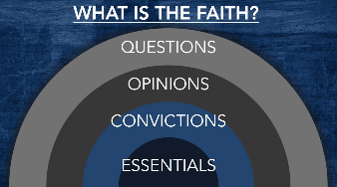

The Big Take-Away:
The Bible provides us with _________________ when choosing a school.
Extend that __________________ to ________________ and to ________________.
Contending for the Faith – Blake Holmes, 8/6/18
Voices to Steer Away From | Voices to Steer Towards

Our Role as Parents:
 | Believe | Belong | Be Trained | Be Strong

Questions and Next Steps:

Recommended Resources:
- “Should I? Making Wise Choices” by Blake Holmes, Watermark Sermon 9/15/2013
- “Real Truth Real Quick: Should I Send My Child to Public, Private, Or Home School?” By Todd Wagner
- Risen Motherhood – How Should We Educate our Children? https://www.risenmotherhood.com/education
- 6 Ways to Show Your Child God’s Design for Ethnic Diversity: https://www.thegospelcoalition.org/article/child-ethnic-diversity/
- FAQ: School Choices in an urban neighborhood: http://www.becca-stanley.com/blog//2014/09/faq-school-choices-in-urban.html
- Going Public: Your Child Can Thrive in Public School by David Pritchard

www.watermark.org/schools schools@watermark.org bsolomon@avid.org

